**PET SHOP INVENTORY AND SALES SYSTEM**

COMPUTER SCIENCE DEPARTMENT

COLLEGE OF SCIENCE

ADAMSON UNIVERSITY

ADVANCED DATABASES

SUBMITTED BY:

Wencel De Lara

Yvan Sinues

John Miguel Jusayan

Vinard James Damasco

SUBMITTED TO:

BILLY JAY B. ANGELES

**Executive Summary**

The Pet Shop Inventory and Sales System represents a sophisticated Windows application tailored to enhance operational efficiency for pet shop proprietors. Designed with an intuitive and user-friendly interface, this system empowers businesses to streamline their processes while ensuring the delivery of exemplary service to stakeholders.

This project's primary objective is to furnish pet shop owners with a bespoke Point-of-Sale (POS) and Inventory management solution, precisely calibrated to meet the unique requirements of their establishment. By furnishing accurate and timely data on sales patterns, inventory levels, and customer interactions, the system facilitates informed decision-making and operational optimization. Notably, the system will feature a Windows-based application interface fortified with robust multi-user access controls, enabling granular restriction of access privileges based on user roles.

The Pet Shop Inventory and Sales System grants users access from their business's personal computers, facilitating comprehensive inventory tracking and management. Key functionalities include integrated alerts for low inventory levels, robust sales management capabilities, comprehensive sales reporting and analytics, seamless access to the point-of-sale interface, and flexible multi-user access management tailored to individual user roles and responsibilities.

**Business Problem**

In the Philippines, there's a thriving community of small-scale pet care businesses scattered across areas like Cartimar, barangays, villages, and more. However, many of these businesses rely on manual inventory and sales methods, which can be inefficient and time-consuming, especially as they aim to expand. That's where we step in – offering an inventory and sales management solution tailored to their needs.

The current business activities of the pet shop encompass various aspects, including inventory management, sales transactions, customer interactions, and operational oversight. These activities are integral to the daily functioning of the establishment and directly impact its profitability, customer satisfaction, and overall success.

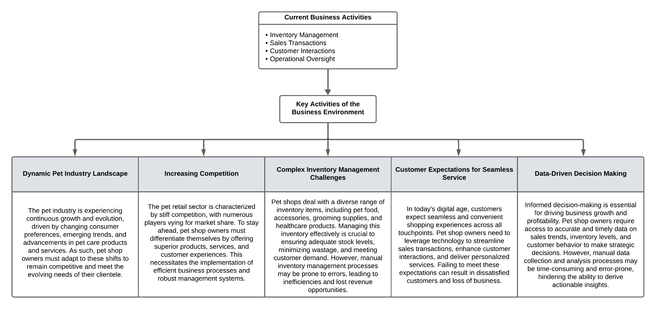

**Environmental Analysis**

The Pet Shop Inventory and Sales System would benefit the company by improving operational efficiency and customer service through simplified inventory management and sales procedures, as well as delivering accurate data on sales trends, inventory levels, and customer behavior. This would make it possible to optimize operations and make well-informed decisions, which would eventually increase profitability and satisfy customers. Unlike many other pet stores, including those located in Cartimar, which continue to use traditional inventory methods, this system offers a cutting-edge substitute that distinguishes the company for its effectiveness and flexibility. In order to ensure effective deployment and usage of the system, the firm may leverage its current technical infrastructure and personnel competency through access to training programs.

Both internal and external factors may impact the Pet Shop Inventory and Sales System's profitability. Its success may be impacted internally by elements including the effectiveness of training initiatives, staff adaptability to the new system, and the efficiency of execution. Profitability may also be impacted by the company's financial resources used for the system's creation and maintenance. The system's pricing strategy and demand may be impacted by external factors such as economic conditions, shifts in customer preferences, and market rivalry. Furthermore, the effectiveness and financial success of the system might be impacted by developments in technology and possible cybersecurity risks. Therefore, optimizing the app's profitability requires careful evaluation of both internal and external aspects.

**Problem Analysis**

This project will focus on creating a software system that will cater to pet shops. A software system that can track inventory levels and orders will enable a business to make those sales. It can also be used to create a work order and keep track of sales, a bill of materials, and other production-related documents.

**Goals and Objectives**

The main objective of this project is to allow pet shop owners to have a more streamlined process in handling their inventory and making organized sales.

The *Pet Shop Inventory and Sales System* is expected to:

1. Achieve an understanding and mastery of the subject fulfillment of our *Advanced Databases* course
2. Provide the business with a customized Point-of-Sales and Inventory system that will fit the needs of the shop with accurate and timely data on sales trends, inventory levels, and customer behavior
3. To be able to assist with the inventory tracking/ management of products with the concerned shop
4. The system will be able to filter inventory levels, product types, and prices from the system’s database
5. To record order transaction history that the store has made

**Scope**

Specified here is the scope of features and solutions that the pet shop inventory system will cover:

* *Inventory Tracking and Control*. Keeping track and control of the in and out movement of the inventory from the business, as well as any changes made to inventory levels
* *Integrated Inventory Alerts*. Automated notifications that alert the user when the inventory levels of a particular product in stock are below the critical level of inventory
* *Sales Management.* The ability of the system to print out receipts and other financial reports.
* *Reports and Analytics.* The ability of the system to provide to and from sales reports.
* *Point of Sales.* Computes an item's price, including any applicable sales tax, and then changes the inventory count to reflect the sale of the item and produce an official receipt.
* *Multi-User Access Control.* Features of the system will vary from user to user depending on their role as dictated by the database.
* *Security.* The system will only be used by authorized users and will be backed up by the SHA-256 algorithm for encryption.

**Detailed Database Design**

**A.Data Dictionary**

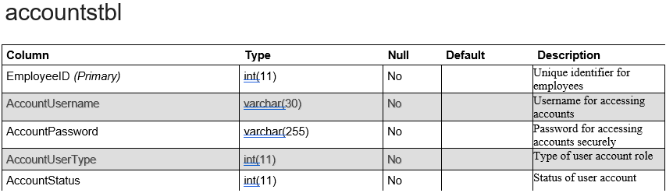

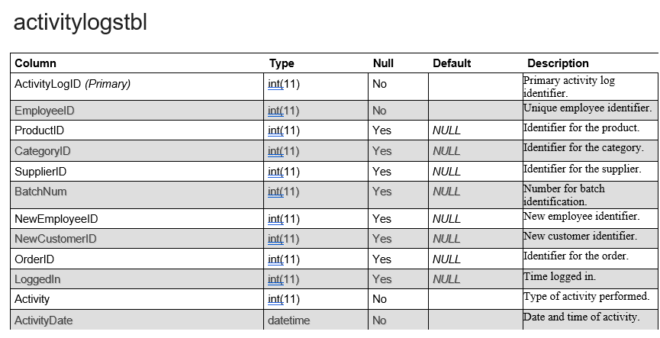

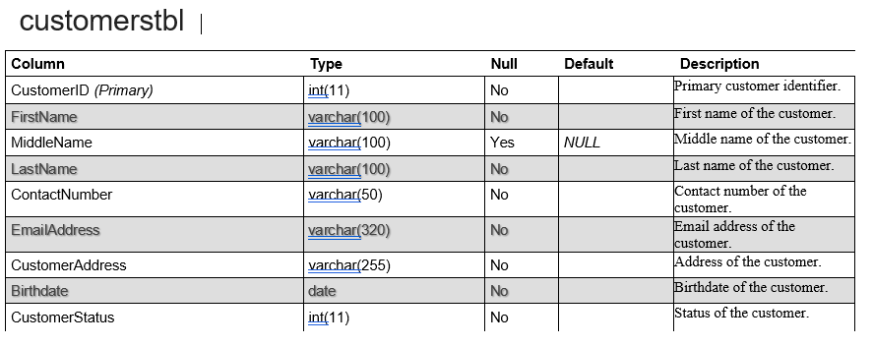

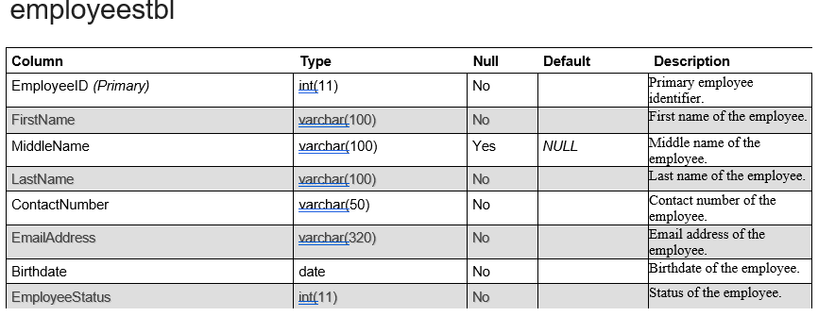

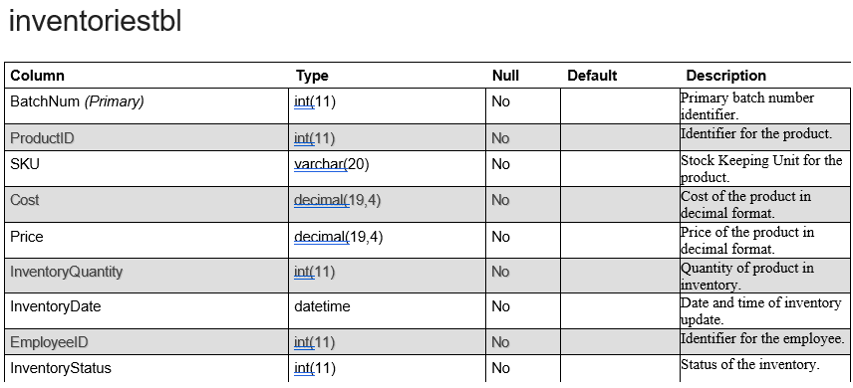

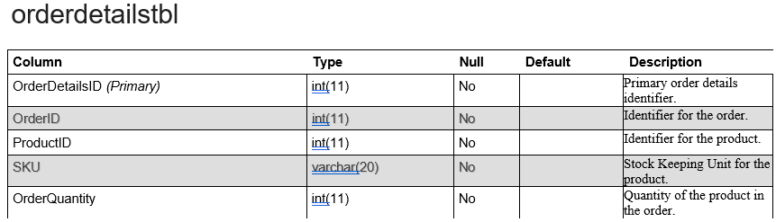

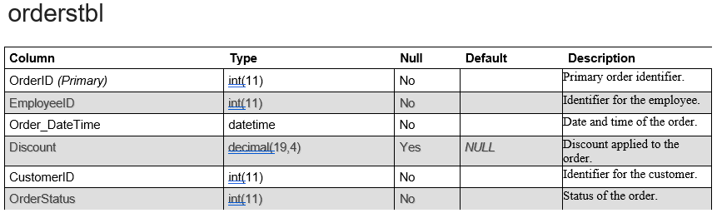

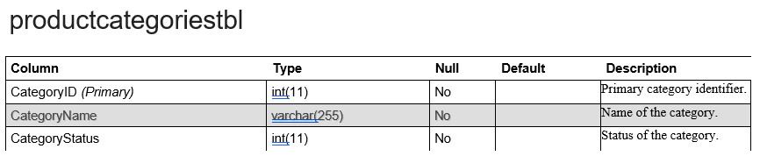

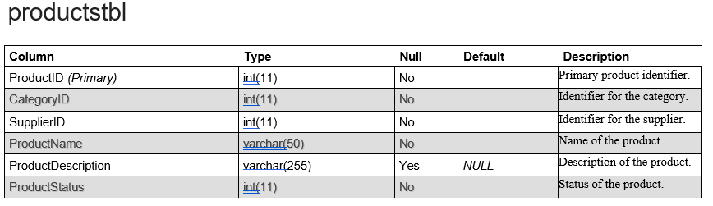

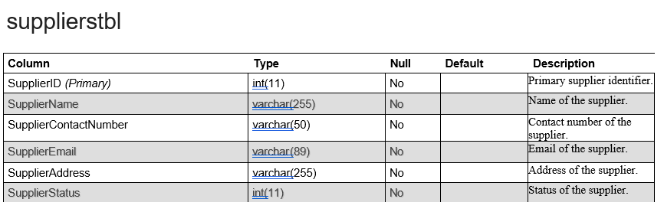

***B. Entity-Relationship Diagram (ERD) / Object Diagram***

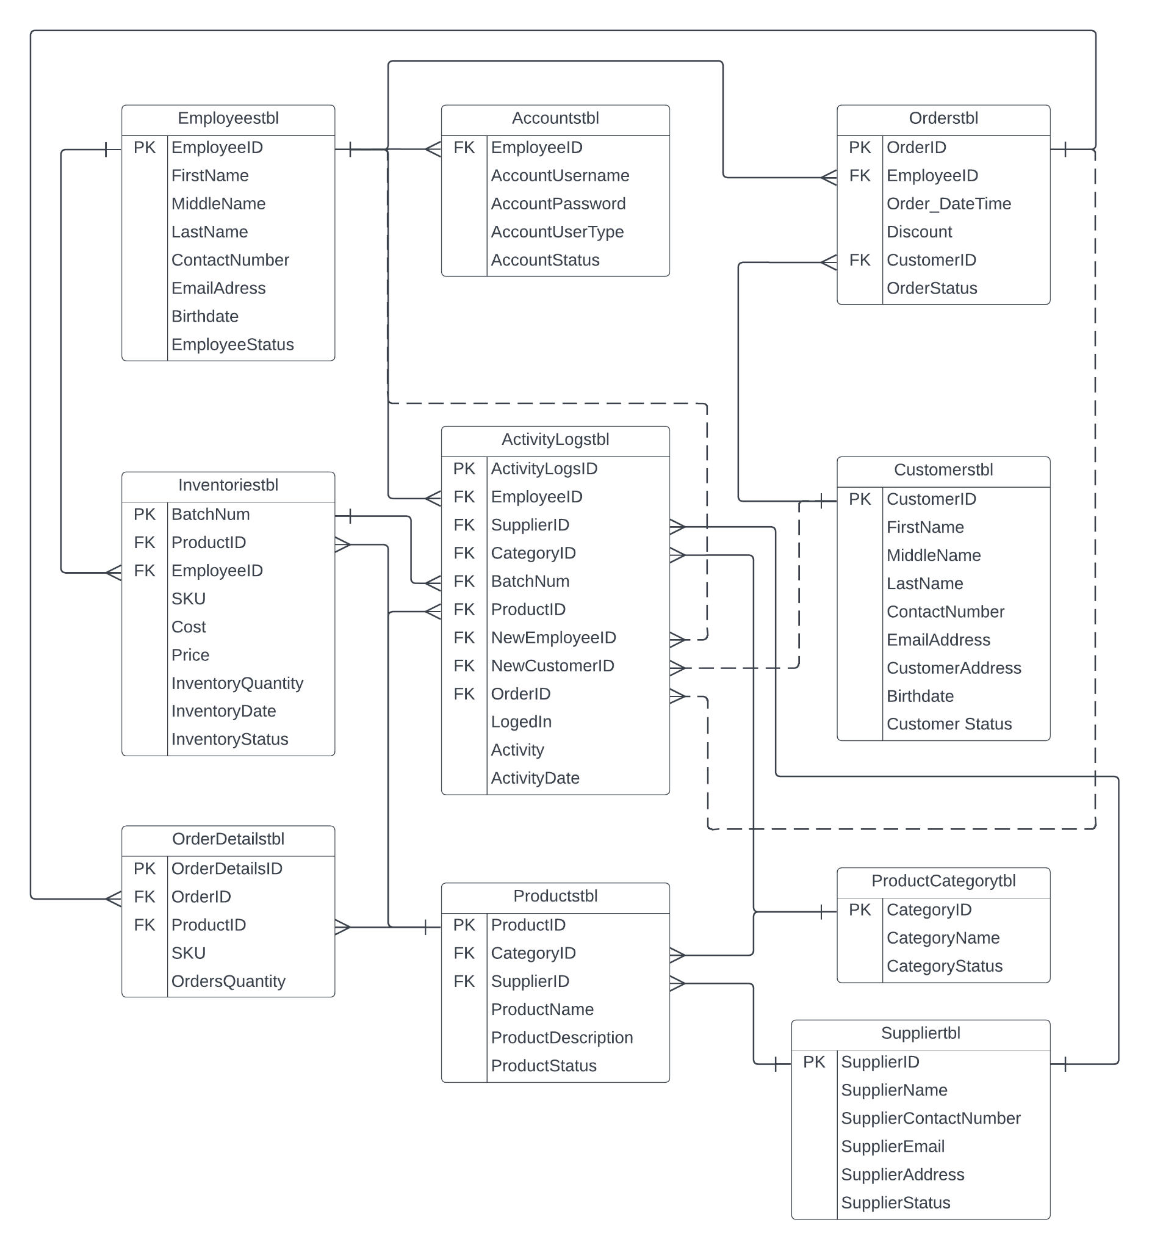

***C. Data Flow Diagram (DFD)***

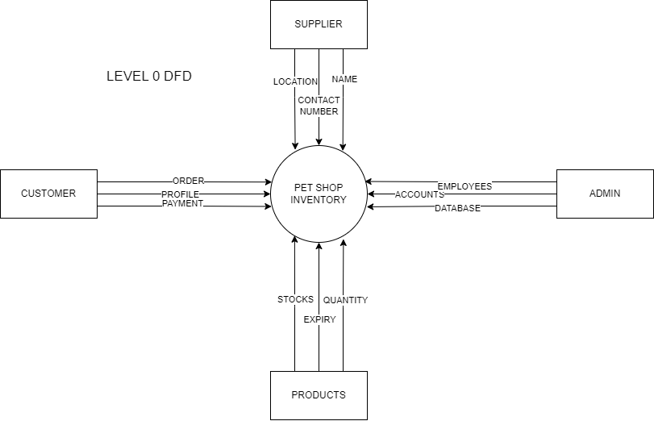

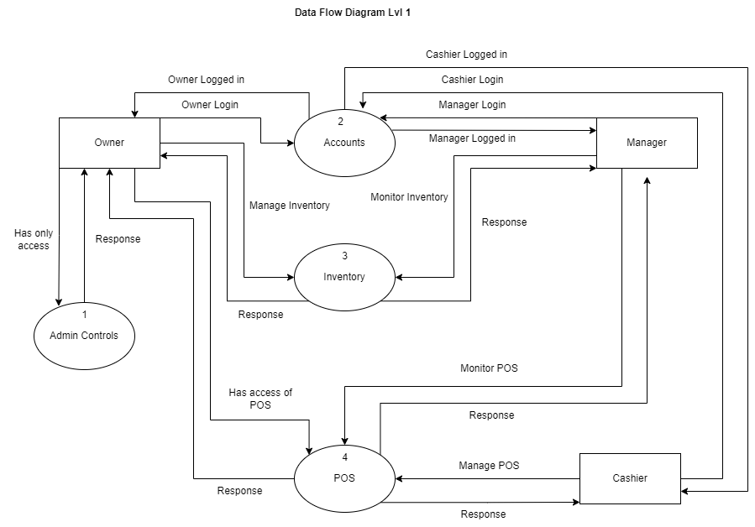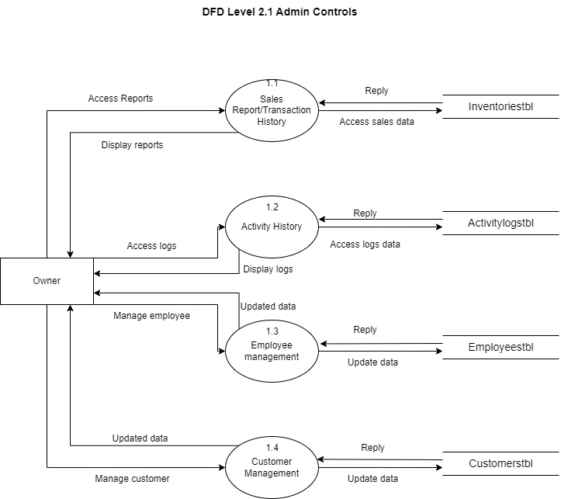

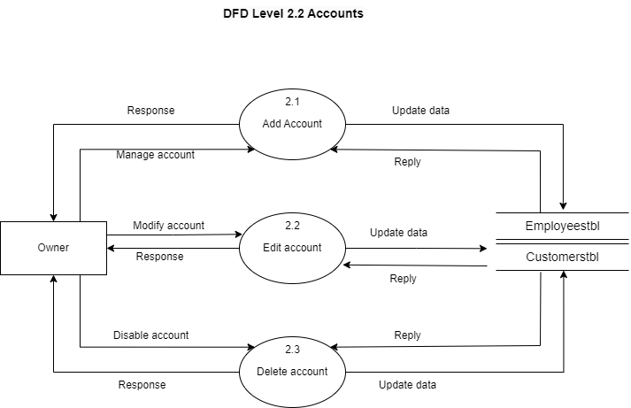

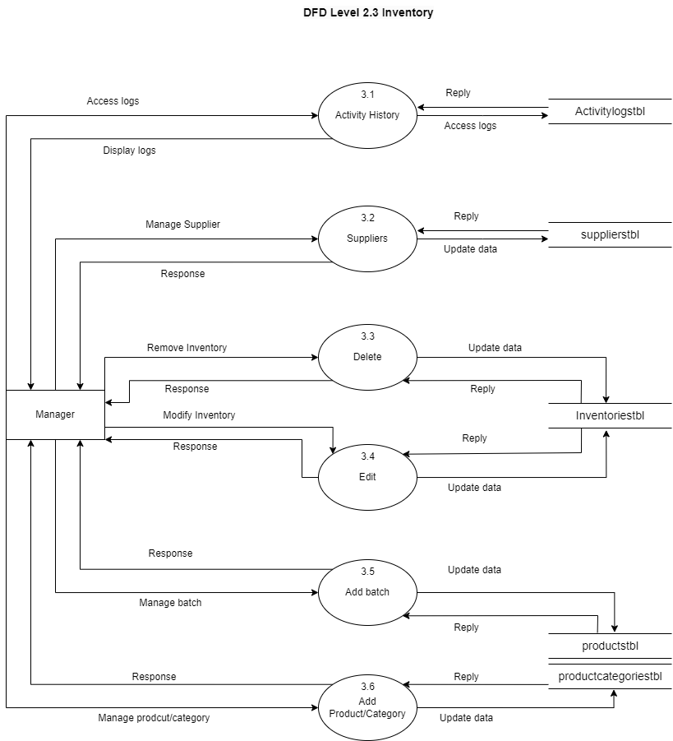

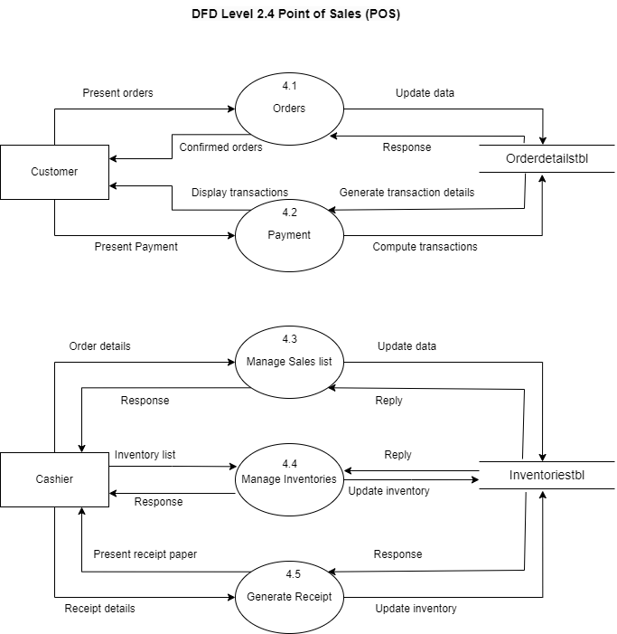

***D. SYSTEM SCREENSHOTS***

**D.1. Module 1 - Sign In**

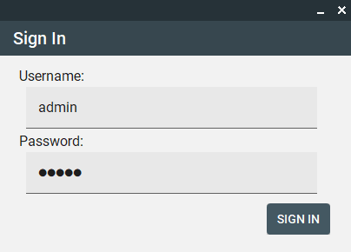

*Fig 1.0*

To access the system, users must provide both their username and password on the sign-in page. All necessary information must be entered to successfully log in

**D.2. Module 2 - Control Panel**

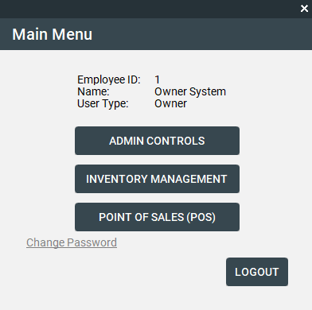

*Fig 2.0*

This page serves as the menu interface, granting users access to their basic information as well as all available controls

**D.3. Module 3.1 - Admin Controls (*Sales Report / Transaction History*)**

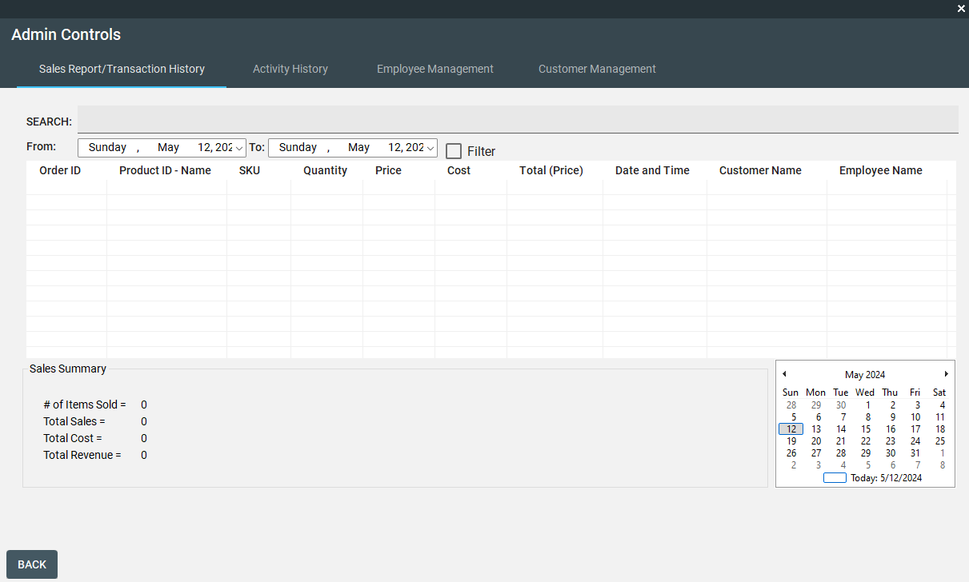

*Fig 3.1*

This page is exclusively designed for users to access comprehensive sales reports and transaction history generated by the system. Users can utilize filters based on date range and product name for streamlined searches. The sales summary provides key metrics including the number of items sold, total sales, total cost, and total revenue, dynamically adjusting based on the applied filters. This page is restricted to administrators only.

**D.3. Module 3.2 - Admin Controls (*Activity History*)**

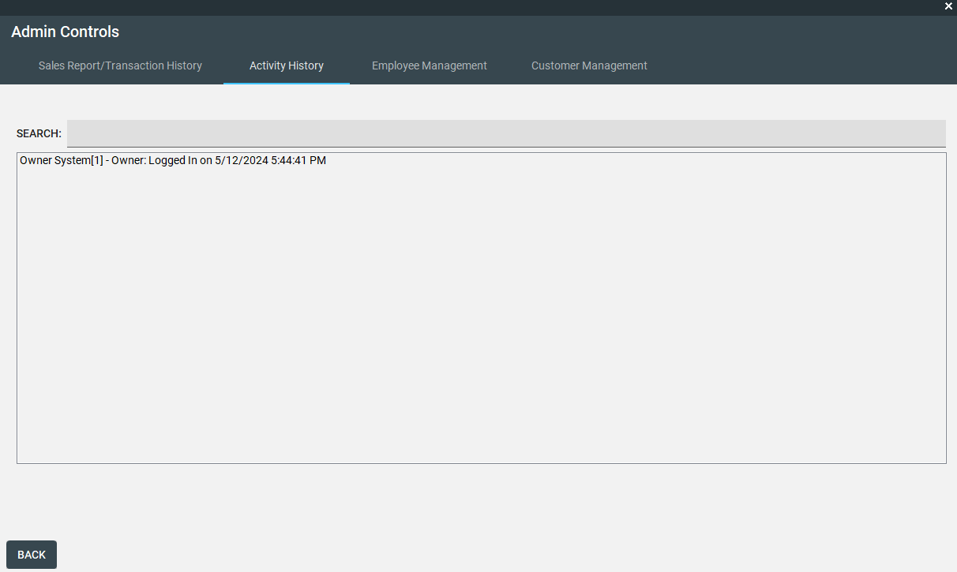

*Fig 3.2*

This page displays a log of all system activities, including login attempts, inventory management actions, sales transactions, and more. This page is restricted to administrators only.

**D.3. Module 3.3 - Admin Controls (*Employee Management*)**

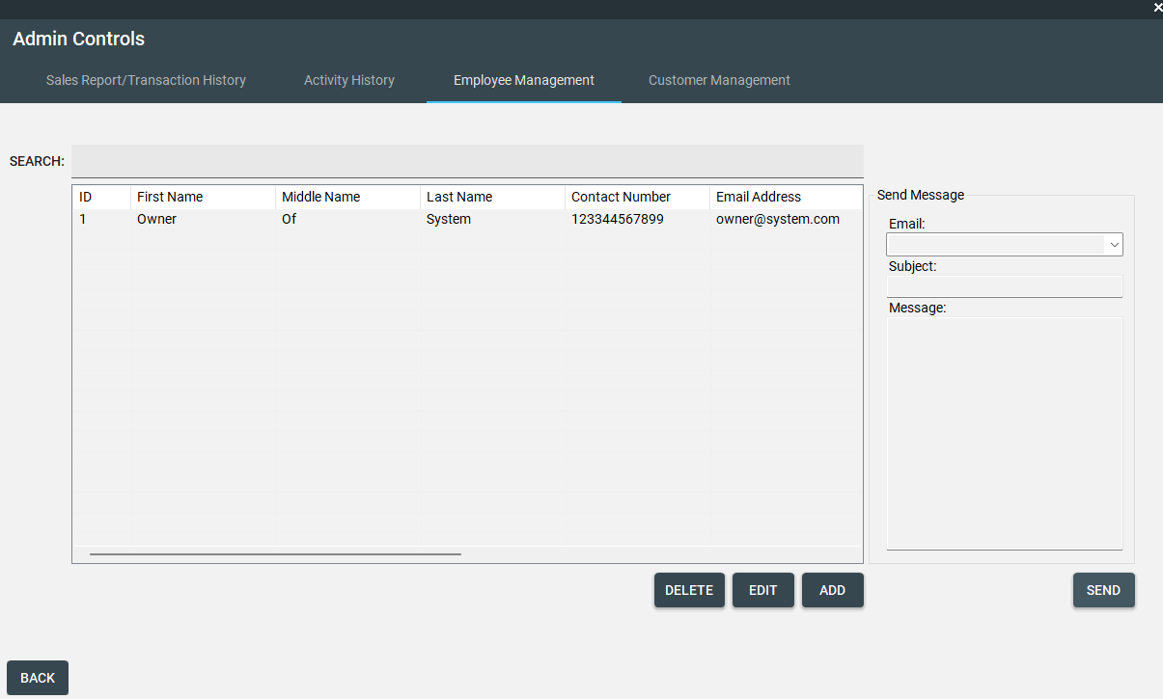

*Fig 3.3*

This page facilitates the management of employees within the system. Users can access comprehensive information about enrolled employees and perform actions such as adding, editing, or deleting user profiles. Additionally, users can send messages to employees using their enrolled email addresses. This page is restricted to administrators only.

**D.3. Module 3.3.1 - Admin Controls (*Employee Management - Add Employee*)**

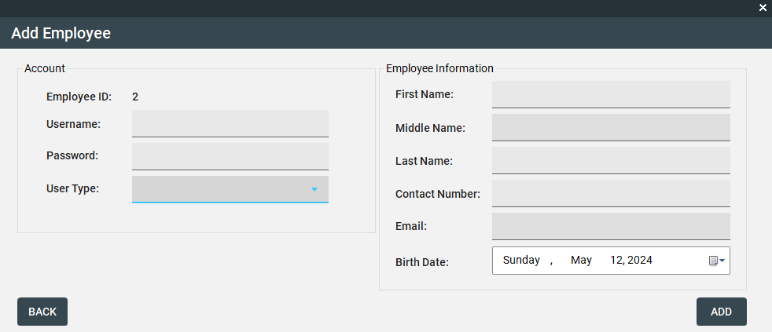

*Fig 3.3.1*

To add an employee to the employee management system, users must input all required fields. Failure to comply with these requirements will prevent the system from proceeding with the request.

**D.3. Module 3.3.2 - Admin Controls (*Employee Management - Edit Employee*)**

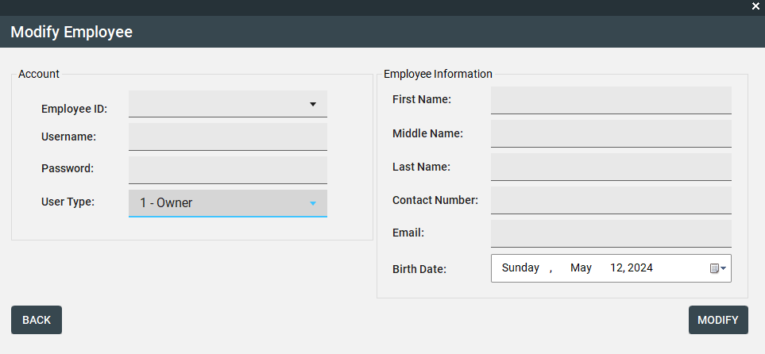

*Fig 3.3.2*

Admin users have the capability to select and edit employee information.

**D.3. Module 3.4 - Admin Controls (*Customer Management*)**

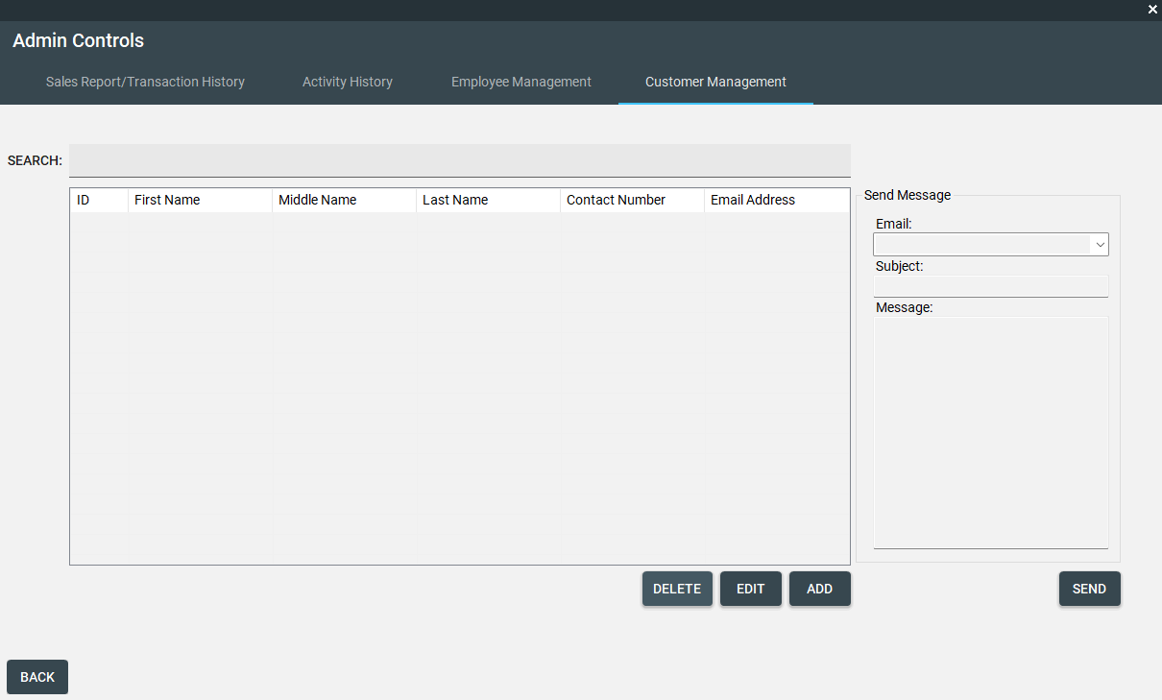

*Fig 3.4*

This page facilitates the management of customers within the system. Users can access comprehensive information about enrolled customers and perform actions such as adding, editing, or deleting user profiles. Additionally, users can send messages to customers using their enrolled email addresses. This page is restricted to administrators only.

**D.3. Module 3.4.1 - Admin Controls (*Customer Management - Add Customer*)**

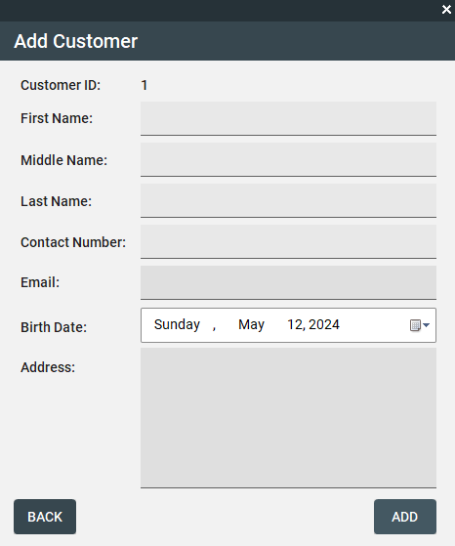

*Fig 3.4.1*

To add a customer to the customer management system, users must input all required fields. Failure to comply with these requirements will prevent the system from proceeding with the request.

**D.3. Module 3.4.2 - Admin Controls (*Customer Management - Edit Customer*)**

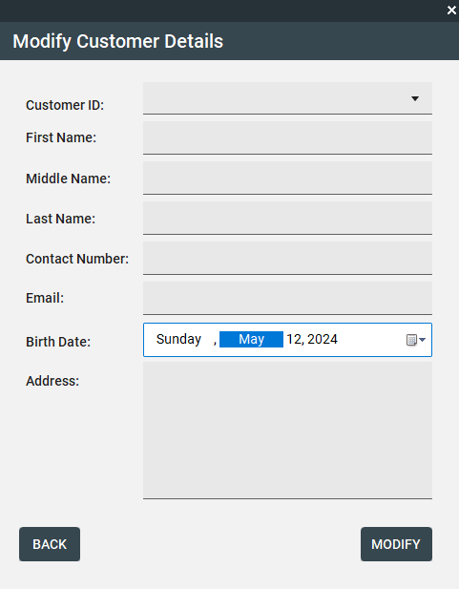

*Fig 3.4.2*

Admin users have the capability to select and edit employee information.

**D.4. Module 4 - Inventory Management**

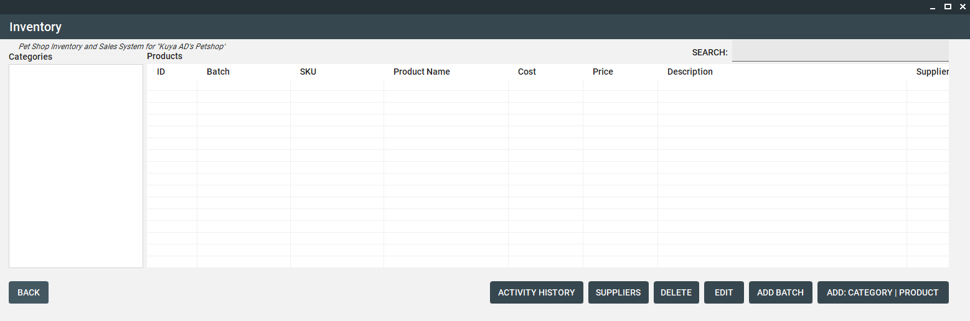

*Fig 4*

This page is dedicated to managing the inventory of the store. It provides tools to organize and oversee the stock of items and services, categorizing them for easy access. Users can view detailed information about each product, search, review activity history, manage suppliers, delete, edit, add batches, and create new categories and products. Access to this module is restricted to administrators and managers.

**D.4. Module 4.1 - Inventory Management (*Activity History*)**

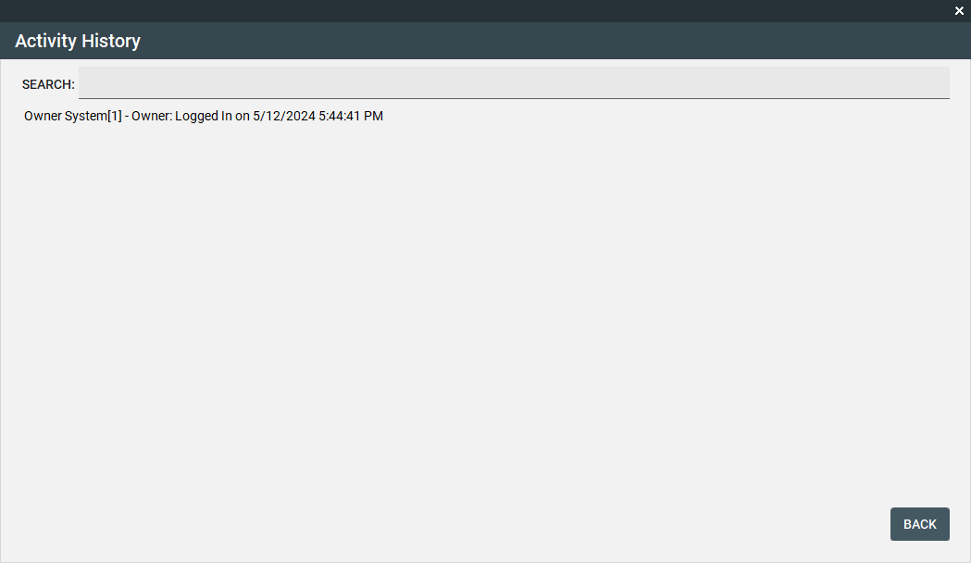

*Fig 4.1*

This page displays a log of all system activities, including login attempts, inventory management actions, sales transactions, and more. This page is restricted to administrators only.

**D.4. Module 4.2 - Inventory Management (*Suppliers*)**

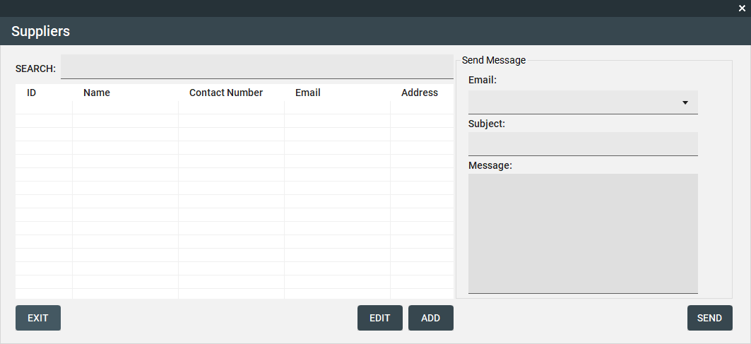

*Fig 4.2*

This page facilitates the management of suppliers within the system. Users can access comprehensive information about enrolled suppliers and perform actions such as adding, editing, or deleting supplier profiles. Additionally, users can send messages to suppliers using their enrolled email addresses.

**D.4. Module 4.2.1 - Inventory Management (*Suppliers - Add*)**

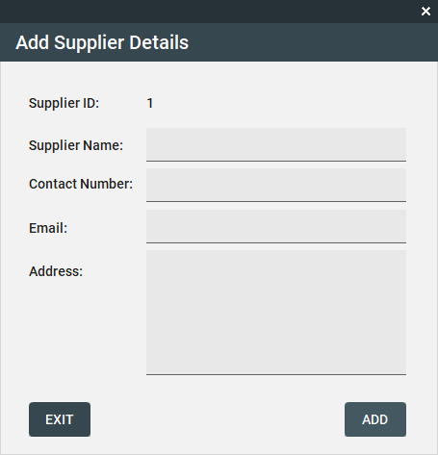

*Fig 4.2.1*

To add a supplier to the supplier management, users must input all required fields. Failure to comply with these requirements will prevent the system from proceeding with the request.

**D.4. Module 4.2.2 - Inventory Management (*Suppliers - Edit*)**

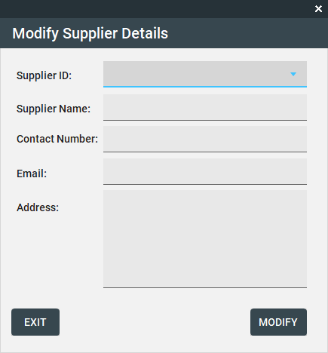

*Fig 4.2.2*

Admin and manager users have the capability to select and edit supplier information.

**D.4. Module 4.3.1 - Inventory Management (*Edit Product*)**

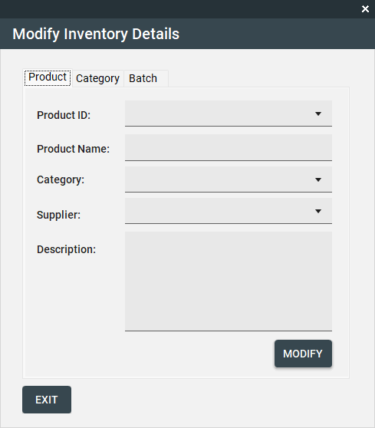

*Fig 4.3.1*

Admin and manager users have the capability to select and edit product information.

**D.4. Module 4.3.2 - Inventory Management (*Edit Category*)**

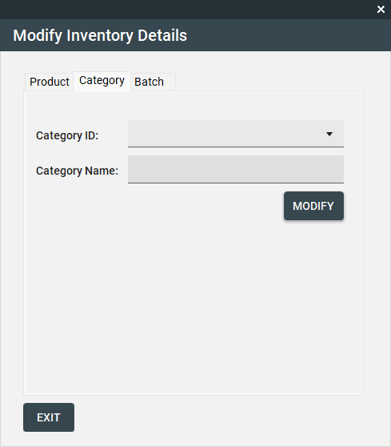

*Fig 4.3.2*

Admin and manager users have the capability to select and edit category information.

**D.4. Module 4.3.3 - Inventory Management (*Edit Batch*)**

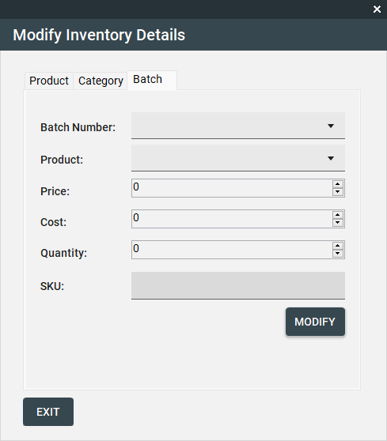

*Fig 4.3.3*

Admin and manager users have the capability to select and edit product batch information.

**D.4. Module 4.4 - Inventory Management (*Add Batch*)**

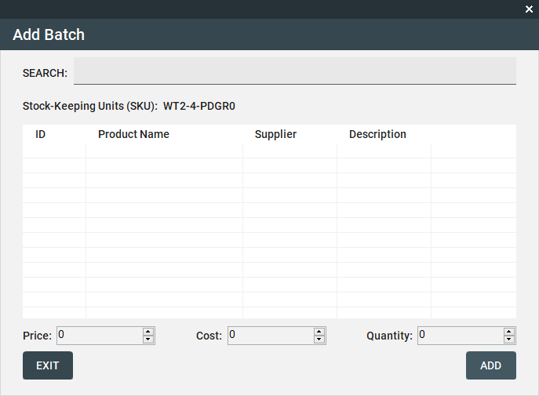

*Fig 4.4*

Users can add batches of specific products to the system, with each product potentially having multiple batches. After searching for a specific product by name, users can input the price, cost, and quantity of the batch, and seamlessly integrate it into the inventory.

**D.4. Module 4.5.1 - Inventory Management (*Add: Product*)**

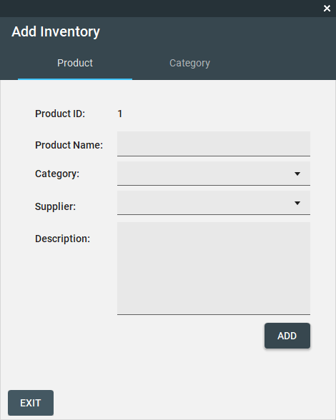

*Fig 4.5.1*

To add a product to the inventory management, users must input all required fields. Failure to comply with these requirements will prevent the system from proceeding with the request.

**D.4. Module 4.5.2 - Inventory Management (*Add: Category*)**

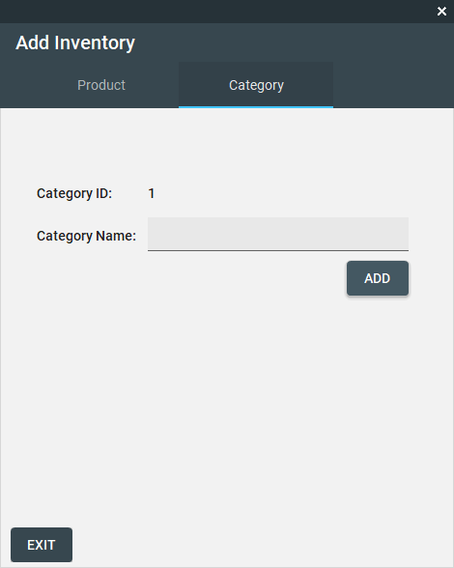

*Fig 4.5.2*

To add a category to the inventory management, users must input all required fields. Failure to comply with these requirements will prevent the system from proceeding with the request.

**D.5. Module 5 - Point of Sales (POS)**

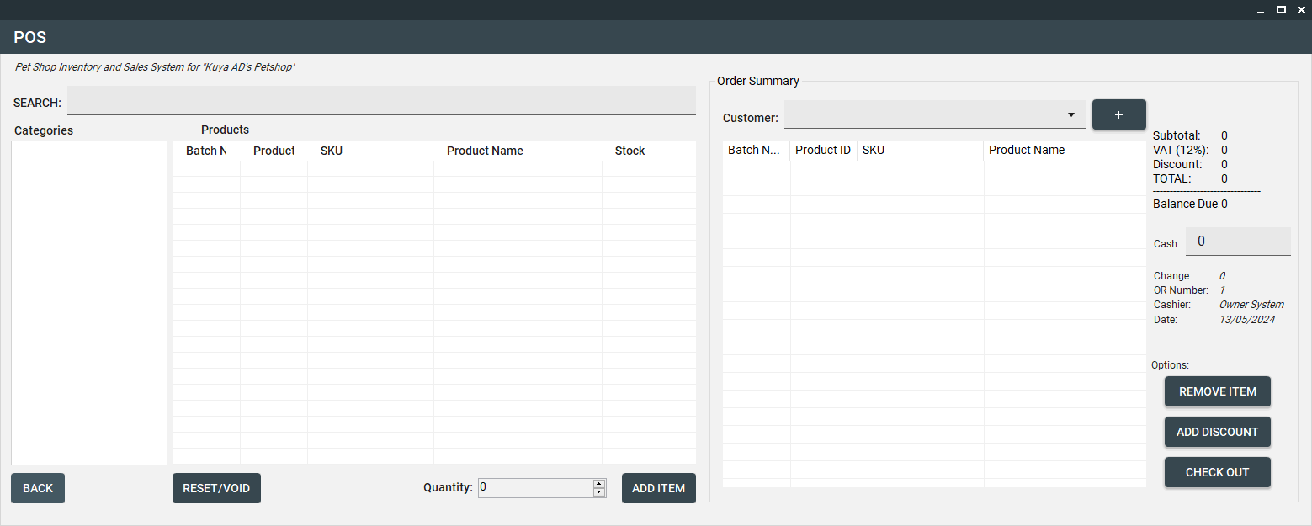

*Fig 5*

The Point of Sales module facilitates system sales and is accessible to all users: Admins, managers, and cashiers. On the left-hand side, users can browse available categories and corresponding products, with a search function available. The right-hand side displays the order summary, showing customer-selected items and their details. Users must select the customer for the order. Here, the subtotal, fixed 12% value-added tax (VAT), discount, and total are displayed. An input field allows entry of the customer's payment, immediately calculating the change due. Additional information includes the order number, cashier's name, and date. Options to remove items, apply discounts, and complete the transaction are available.

**D.5. Module 5.1 - POS (*Add Discount*)**

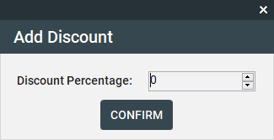

*Fig 5.1*

Users have the ability to input the percentage of discount to be applied to the customer's purchase.

**D.5. Module 5.2 - POS (*Add Customer*)**

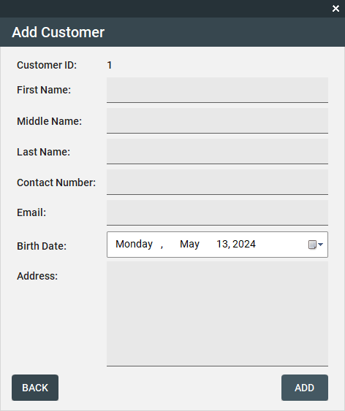

*Fig 5.2*

To add a customer to the customer management system from the POS, users must input all required fields. Failure to comply with these requirements will prevent the system from proceeding with the request.